Assignment  
PhoneGap in Action: Contact Manager

# Install JQuery Mobile

Download and install latest version of JQuery Mobile (JQM)

# App structure

## Create 2 JQM page for Contact List and Contact Detail

<div data-role="page" id="list">

<div data-role="page" id="detail">

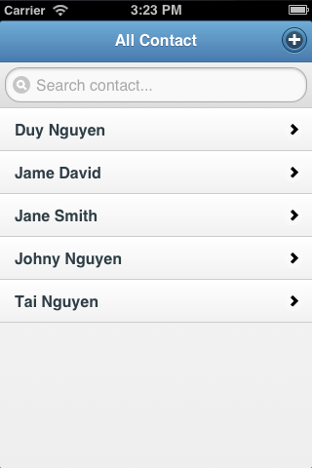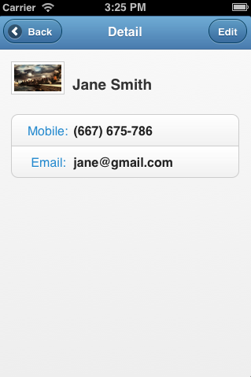

## Create Listview for rendering Contact List

<ul id="list-contact" data-role="listview" data-filter="true" data-filter- placeholder="Search contact..." class="ui-icon-alt">

## Create template for Contact Detail view

<div class="clearfix">

<img id="fnPhoto" />

<h3 id="fnName"></h3>

</div>

<div data-role="controlgroup">

<a data-role="button">

<u>Mobile:</u>

<b id="fnMobile"></b>

</a>

<a data-role="button">

<u>Email:</u>

<b id="fnEmail"></b>

</a>

</div>

# Access device Contact via PhoneGap API

## Permission

**iOS**

config.xml

<plugin name="Contacts" value="CDVContacts" />

**Android**

app/res/xml/config.xml

<plugin name="Contacts" value="org.apache.cordova.ContactManager" />

app/AndroidManifest.xml

<uses-permission android:name="android.permission.GET_ACCOUNTS" />

<uses-permission android:name="android.permission.READ_CONTACTS" />

<uses-permission android:name="android.permission.WRITE_CONTACTS" />

## DeviceReady

Ensure that you use PhoneGap API after deviceready

document.addEventListener('deviceready', this.onDeviceReady, false);

## Query and render Contact list

Query:

var options = new ContactFindOptions();

options.filter = "";

options.multiple = true;

var fields = ['id', 'name', 'phoneNumbers', 'emails', 'photos'];

navigator.contacts.find(fields, onSuccess, onError, options);

Render:

for (var i = 0; i < contacts.length; i++) {

var c = contacts[i];

s += '<li><a href="#detail" data-ci="' + c.id + '">'

+ c.name.formatted + '</a></li>';

lc[c.id] = c;

}

$('#list-contact').html(s).listview('refresh').trigger("create");

## Contact Detail

$(document).on('tap', 'a[data-ci]', function () {

contactId = $(this).data('ci');

var c = lc[contactId];

$('#fnName').html(c.name.formatted);

$('#fnMobile').html(c.phoneNumbers[0].value);

//...

});

# Homework

Finish Add new contact and Edit contact feature ☺